

phpMyAdmin

User Guide

Prepared by The Woodland Rangers

UGA MBT Capstone Project

April 28, 2018

**Introduction**

The purpose of this document is to give guidance to the administrator on using the phpMyAdmin interface available on the 1and1.com site to manage the FSGW database.

phpMyAdmin is a free software tool written in PHP that is intended to handle the administration of MySQL over the World Wide Web. phpMyAdmin supports a wide range of operations with MySQL. The most frequently used operations are supported by the user interface (managing databases, tables, fields, relations, indexes, users, permissions, etc.), while you still have the ability to directly execute any SQL statement.

Through the phpMyAdmin Control Panel, you can

* browse and drop tables, views, fields, and indexes
* create, copy, drop, rename and alter tables, fields, and indexes
* execute, edit and bookmark any SQL-statement, even batch-queries
* manage MySQL users and privileges
* manage stored procedures and triggers

Refer to these sites for more information concerning phpMyAdmin:

<http://www.phpmyadmin.net/home_page/docs.php>

<http://wiki.phpmyadmin.net/pma/Welcome_to_phpMyAdmin_Wiki>

The database for the volunteer and friends information that is accessible by the Volunteer Application and Admin Tool Box is called FSGWData. To access the database, log in to the 1and1.com Control Panel. On the left-side menu bar of the control panel, click on “MySQL Database.”

**The Database**

There are two databases that are associated with the site:

* WordPress database called Fresh root WP install (db360322876)
* MySQL database that stores the friends and volunteer profile and hours information called FSGWData (db358933030)

Click on the “Open” link under phpMyAdmin column of MySQL Database to access the database administration utilities.

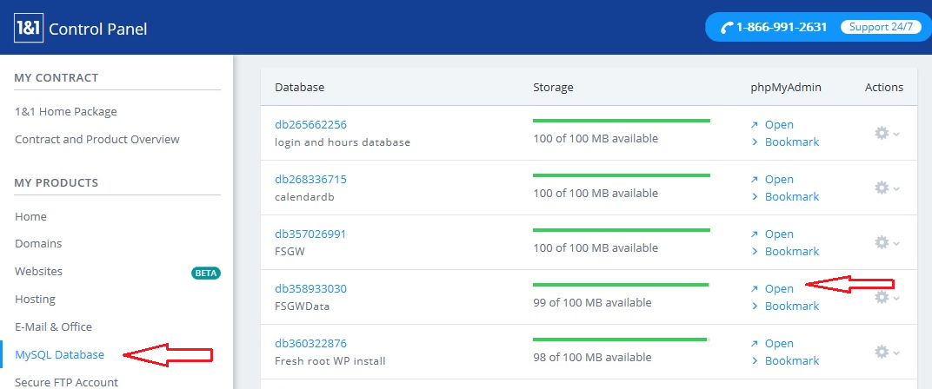

**The Tables**

Inside phpMyAdmin, you will see the information about the configuration of the database and a listing of the database tables. By clicking on one of the table names, you can access the information pertaining to that table.

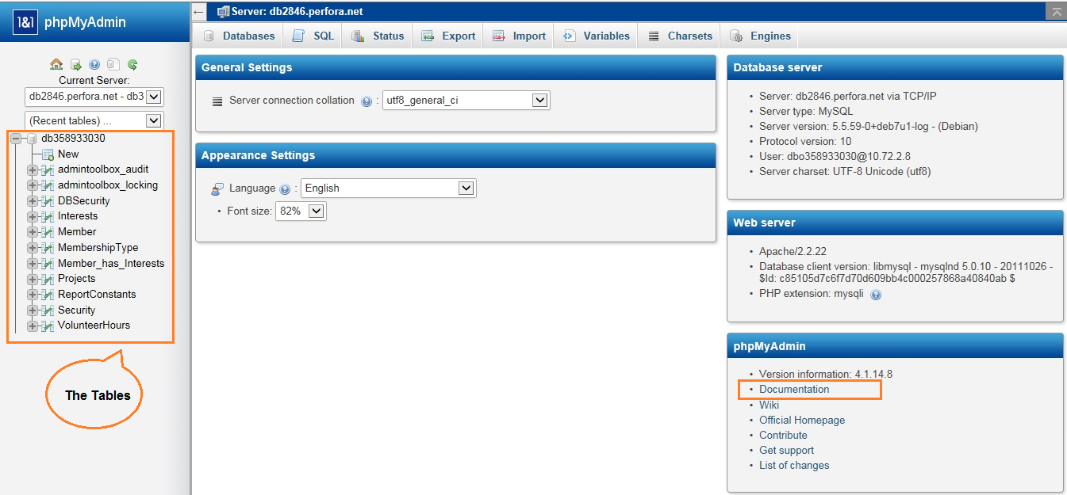

A brief description of the tables is noted below. For more detailed information of the tables and their data fields, please refer to the Data Dictionary in Appendix B.

|  |  |
| --- | --- |
| **Table Name** | **Description** |
| admintoolbox_audit | A table that stores the log file data tracked by the Admin Tool Box |
| admintoolbox_locking | A table that stores the locking info used to lock tables while editing |
| DBSecurity | Usernames, encrypted passwords and emails for Admin Tool Box |
| Interests | 14 areas of interest defined by FSGW that volunteers can identify |
| Member | Main table with the profile information of the friends and volunteers |
| MembershipType | Friends of Georgia State Parks membership levels |
| Member_has_Interests | Many-to-many relationship of members and their interests |
| Projects | A listing of projects as defined by FSGW |
| ReportConstants | Listing of report constants to be used for reports submitted to the State. *Currently not used.* |
| Security | Usernames, encrypted passwords and emails for Volunteer App |
| VolunteerHours | Volunteer activities for Smithgall Woods and Hardman Farm |

When working with the tables and reports, it is important to understand the relationship between the database tables or entities. By reviewing the data model, you can understand the information stored in the database. For a copy of the data model with no notations, please refer to Appendix A.

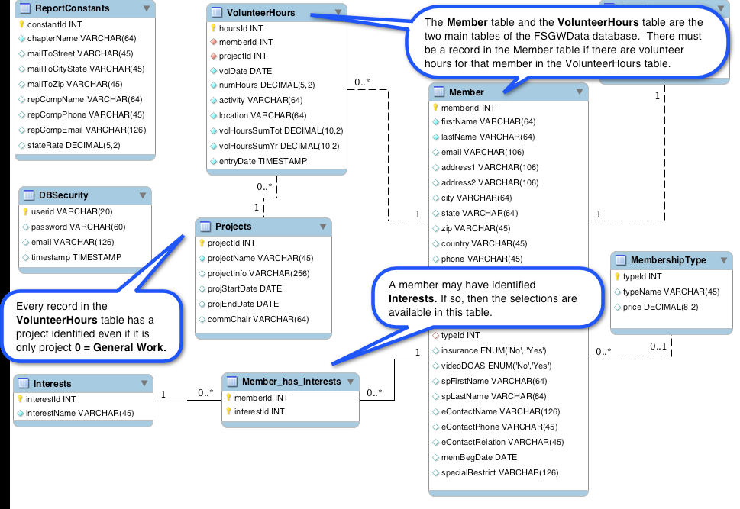

**phpMyAdmin Utilities**

When you click on the table name (i.e. Member), a listing of the table elements is provided in a window with various tabs. The “Structure” tab lists the table elements and their details. You can also modify the elements through this window by the Action buttons.

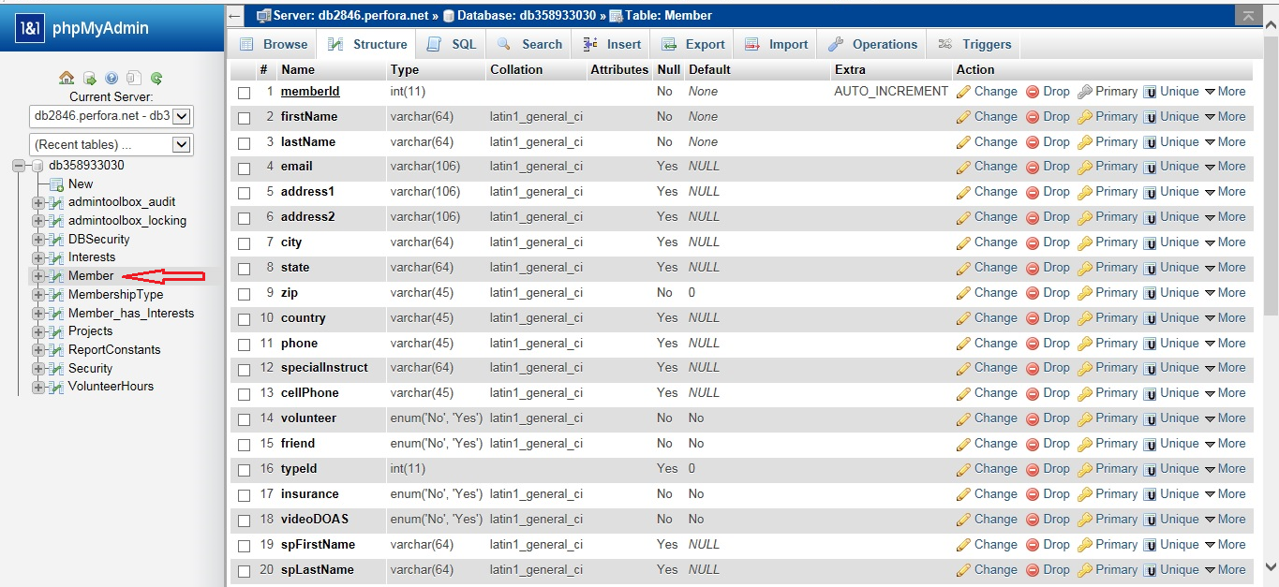

**Tab Definitions**

**1. Browse – Change or Delete a record**

The “Browse” tab will be the most used tab by admin support. Information stored in the database may need to be changed or deleted. *NOTE: A record in the Member table cannot be deleted without first deleting any associated records in the Security, VolunteerHours, and Interests tables. Delete with caution since the Volunteer Hour information will no longer be available once deleted from the table.*

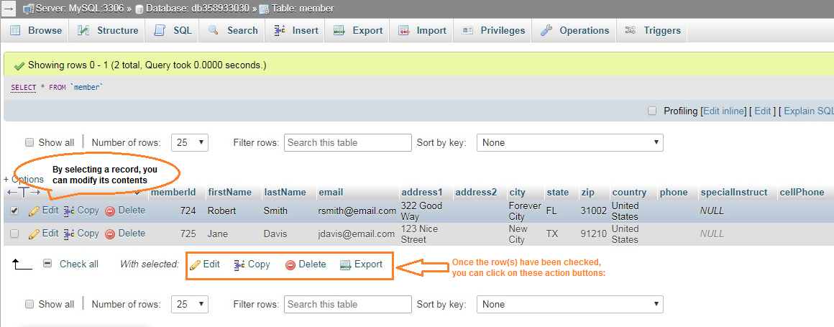

When the “pencil” (Edit link) is clicked, a screen with the field contents for that record is displayed. You can change the information or delete the information from the screen. When all changes are complete, click on “Go” to save your changes.

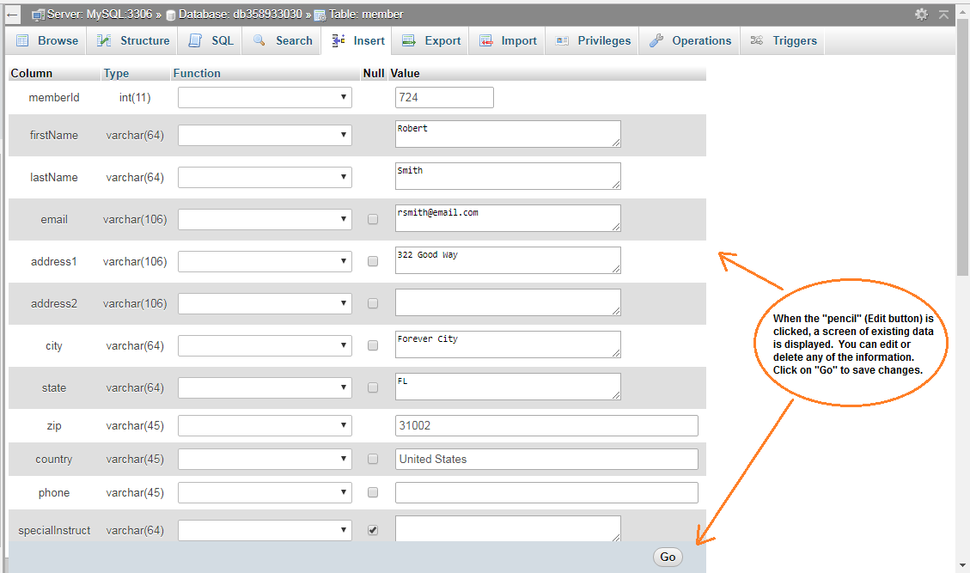

**2. Structure – Change or Drop an element definition**

Changing or dropping a table element is *NOT recommended* since the Volunteer App code and the Admin Tool Box configurations are defined using this table structure and the field definitions. If these table elements change, the Volunteer App and Admin Tool Box may no longer work.

**3. SQL – Window for adhoc SQL queries**

The SQL tab provides a window for custom or adhoc queries. The window lists the available fields in the table for selection.

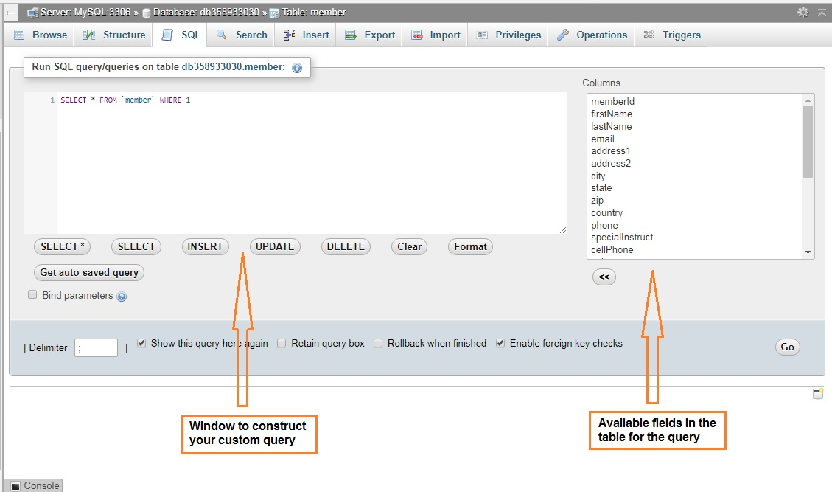

**4. Search**

Search provides an easy to use menu to search the table for specific values. All fields are available for search. This will be a useful tab when trying to find a specific record in a large table like Member with over 200 records.

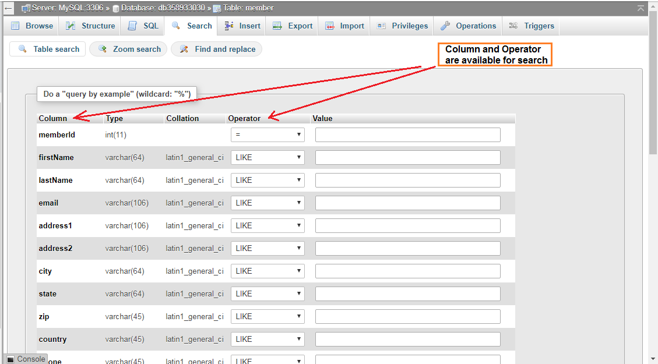

**5. Insert**

The Insert tab provides an easy to use menu to add a new record to the table. The fields that are required are noted by not having the Null column checked. Fields that have predefined defaults are already filled in.

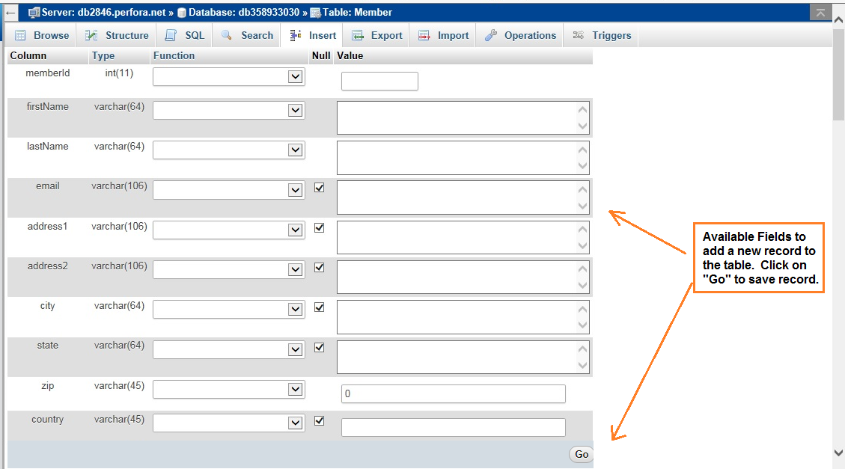

**6. Export**

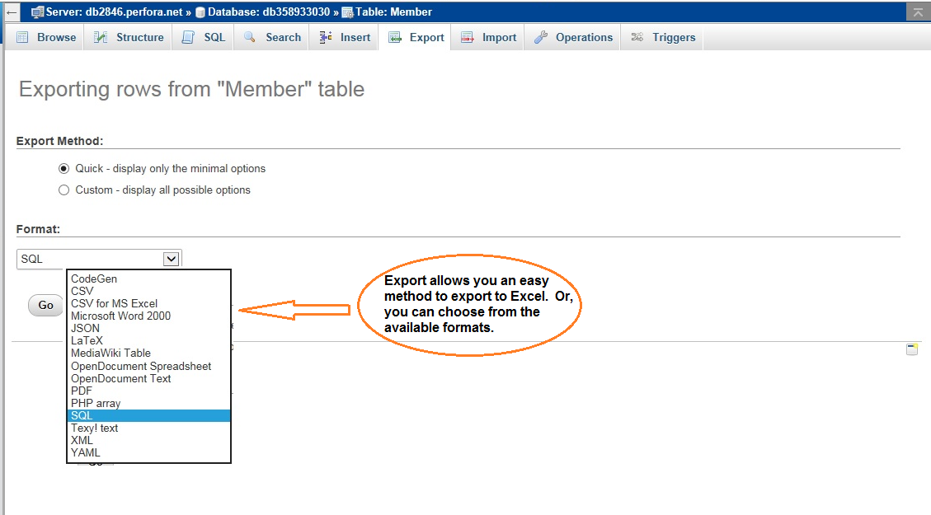

**7. Import**

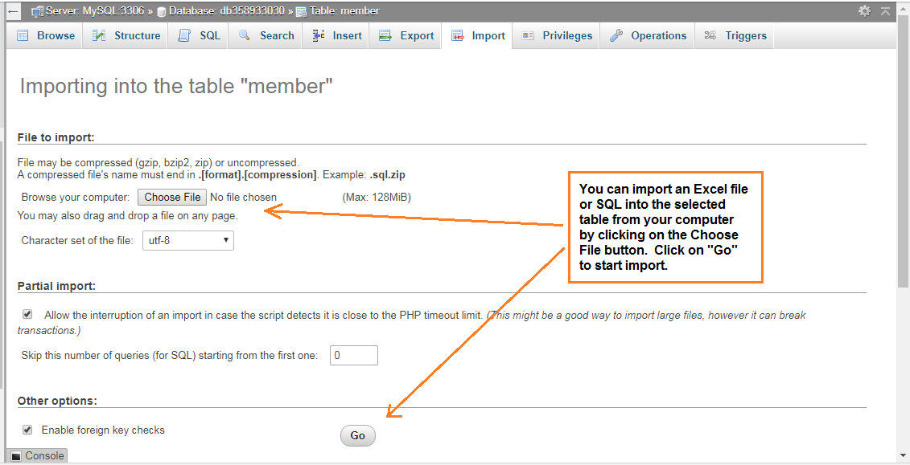

**8. Operations**

Operations tab provides the following table maintenance functions:

* Rename
* Copy
* Move
* Defragment
* Delete

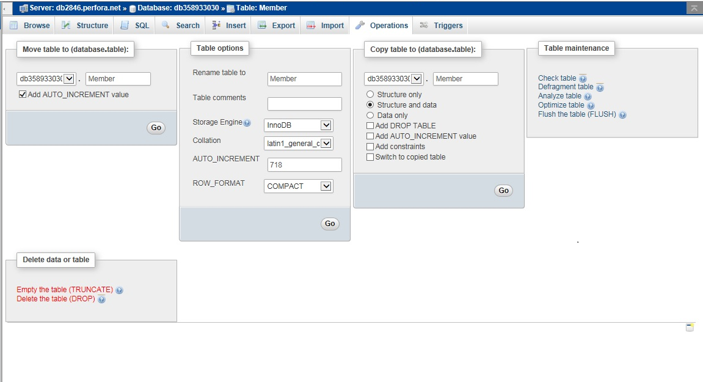

**Appendix A: FSGW Data Model**

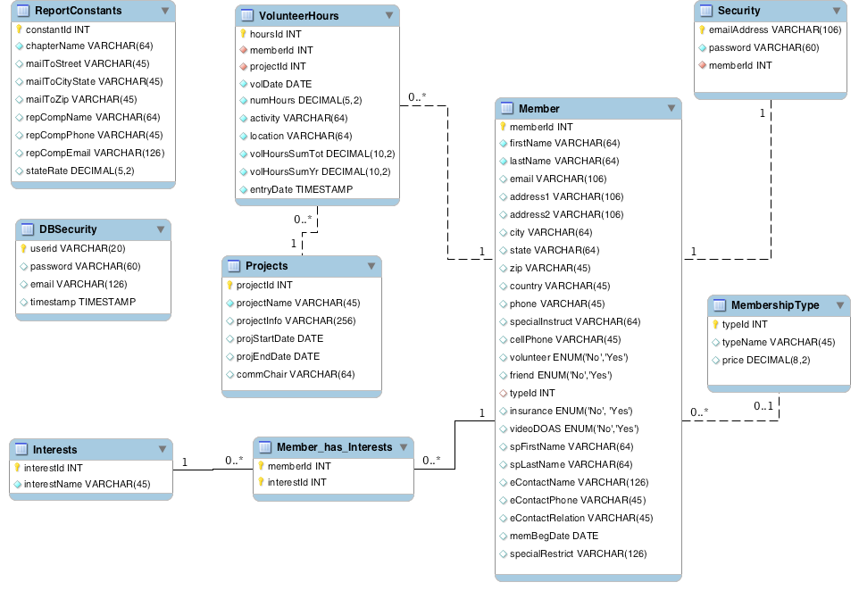

**Appendix B: FSGW Data Dictionary**

